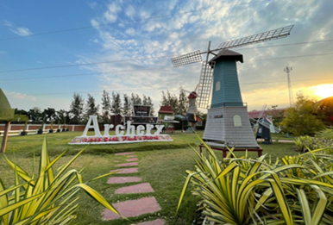
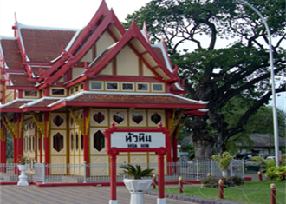
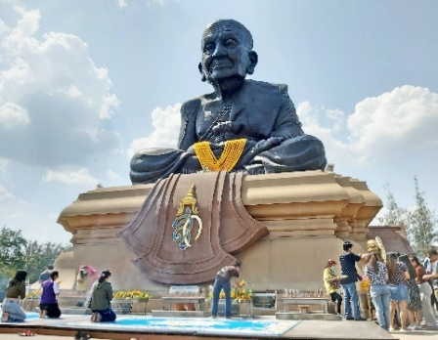
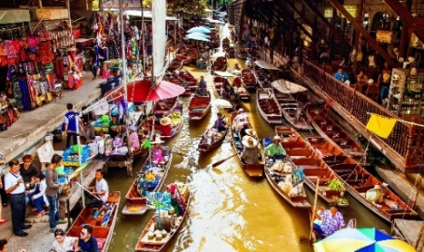
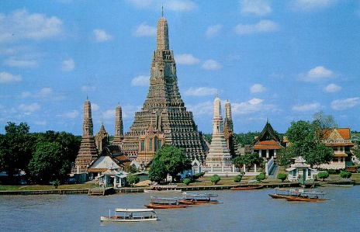
Bangkok -Hua Hin (4Day3night) Private
Private Tour - Code: HHN – 04
Tour highlight: Wat Arun/ Damnean Saduk Floating Market / Zucata Sheep Farm /SuanSun Padipat Beach
Day 01 Flight arrive to/BANGKOK ( Morning-Afternoon Flight )
Assemble at airport and take your flight to Bangkok.
Visit to Wat arun by shuttle boat, Asiatique riverfront or Bantad thong Night Street food
lunch & Dinner by own

Day 02 BANGKOK/HUA HIN (B/L/D)
Hotel Breakfast, DamnoenSaduak Floating Market (include boat ride) here you will be fascinated by boats of various shapes and sizes used by local merchants to ferry their goods
Maeklong Railway Market: This is a unique market that is held every day literally on the rail tracks.
Zucata Sheep Farm: It makes a pleasant stop for you to get right in there amongst the cuddly sheep, feed them some grass, or offer a bottle of milk to a little lamb. It’s a great place to stretch one’s legs and take some deep breaths of country air after escaping the bustling, booming capital.

Venezia, Top ways to experience The Venezia Hua Hin & Cha-am.

Huahing Night Market Or PATIO OLD TOWN

Day 03 HUAHIN -BANGKOK (B/L/D)
Hotel breakfast, SuanSon Padipat Beach or HatSainoi Beach
Hua Hin Railway Station: One of the country’s most beautiful train stations marked by its meticulous details in architecture. Wat Huay Mongkol: This Buddhist temple is home to the world’s largest statue of Luang Phor Thuad, a legendary southernThai monk revered for his enlightenment and ability to perform miracles. Many believe that the amulets created in his image guarantee safety in times of distress perspective.
1000 sook food Farm restaurant. Shopping for local Thai product &Thai desert (NO shopping stop) after lunch transfer to Bangkok approx. 2.30 hrs , Shopping Platinum mall, Joodfar Night Market OR CENTRAL PARK *New shopping mall

Day 04 BANGKOK- Departure (B) Free leisure time, Transfer to Airport for flight dept

